Lesson 3: Inequalities
Math 2412 Precalculus · Unit 1: Algebra Foundations & Functions · Student Guided Notes
Name: ______________________________ Date: ______________

Lesson objective
Students will solve linear, compound, polynomial, rational, and absolute value inequalities, solve absolute value equations, and write solutions in interval notation.

Before class
Complete these short tasks before the lesson. They review skills this lesson builds on.
- Solve three linear equations: $3x−7=11$, $5−2x=9$, and $\frac{x}{4}+1=3$.
- Factor $x^{3}−4x$ and $x^{2}+5x+6$.
- Write $\frac{3}{x−2}−1$ as one fraction (Lesson 1).
- Watch a short video on interval notation, or read the table in Skill 3.1 before class.

Skill 3.1: Interval Notation

Key ideas
- A parenthesis ( ) means the endpoint is ______________ (1). On a number line it is an open circle.
- A bracket [ ] means the endpoint is ______________ (2). On a number line it is a closed (filled) circle.
- ∞ and −∞ are not numbers, so they always get a ______________ (3).
- The symbol ∪ (union) joins two intervals. It means "or."
Inequality | Interval notation | Number line
$x<a$ | (−∞, a) | open circle at a, shade left
$x≤a$ | ________ (4) | closed circle at a, shade left
$x>a$ | ________ (5) | open circle at a, shade right
$x≥a$ | [a, ∞) | closed circle at a, shade right
$a<x<b$ | ________ (6) | open circles, shade between
$a≤x<b$ | ________ (7) | closed at a, open at b, shade between
all real numbers | (−∞, ∞) | shade the whole line

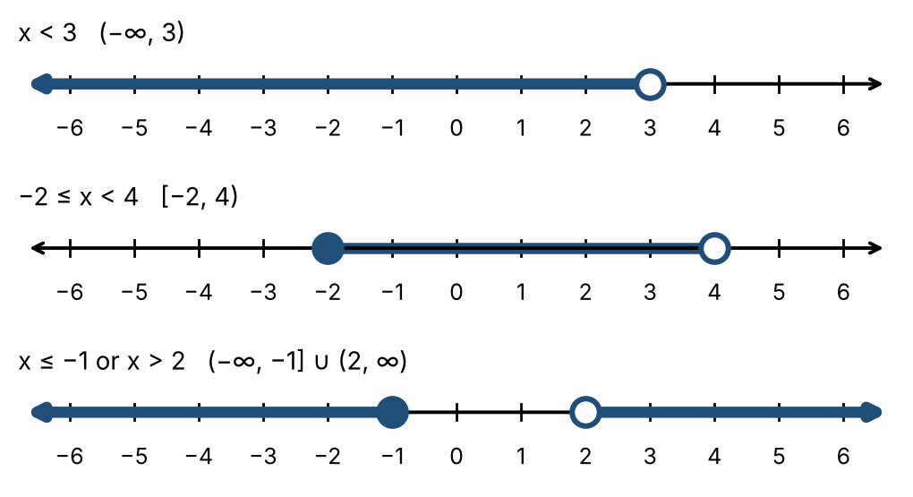

Practice
Write each in interval notation and graph it.
a. $−3≤x<5$  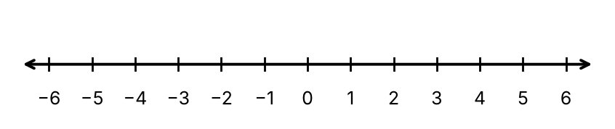 | b. $x>−1$
c. $x≤2$ or $x>6$ | d. Write [0, 4) as an inequality.

Skill 3.2: Linear & Compound Inequalities

Key ideas
- Solve a linear inequality the same way as a linear equation, with one exception.
- When you multiply or divide both sides by a ______________ (8) number, reverse the direction of the inequality.
- A compound inequality such as $3<2x+2<6$ has three parts. Do the same operation to ______________ (9) parts.

Steps: solve a linear or compound inequality
- Isolate the variable using the same steps as for an equation.
- If you multiply or divide by a negative number, flip every inequality sign.
- For a compound inequality, keep the variable alone in the middle.
- Write the answer in interval notation and graph it.

Example 1: solve $13−7x≥10x−4$
$17≥17x$, so $1≥x$. Answer: $x≤1$, or (−∞, 1].

Example 2: solve $4≤3x−2≤13$
Add 2 to all three parts: $6≤3x≤15$. Divide by 3: $2≤x≤5$, or [2, 5].

Practice
Solve. Write the answer in interval notation.
a. $3<2x+2<6$ | b. $−2x+5>11$
c. $\frac{x}{3}−\frac{1}{2}≤\frac{x}{4}+1$ | d. $−1≤\frac{2−x}{3}<4$

Skill 3.3: Polynomial & Rational Inequalities (Sign Charts)

Key ideas
- A polynomial or rational expression can change sign only at its ______________ (10) and, for rational expressions, where the denominator is zero.
- These values split the number line into intervals. On each interval the sign stays the same, so one ______________ (11) tells the sign of the whole interval.
- Values that make a denominator zero are never included, so they always get a ______________ (12).

Steps: solve with a sign chart
- Move every term to one side so the other side is 0.
- For a rational inequality, combine into a single fraction. Never multiply both sides by an expression with x.
- Factor. Find the values where the numerator is zero and where the denominator is zero.
- Mark these values on a number line. Choose a test value in each interval and find the sign.
- Write the intervals with the sign you need. Include zeros of the numerator for ≤ or ≥; never include zeros of the denominator.

Example 1: solve $x^{2}+5x+6>0$
Factor: $(x+3)(x+2)>0$. Zeros: $x=−3$ and $x=−2$.
Interval | Test value | Sign of x + 3 | Sign of x + 2 | Product
(−∞, −3) | −4 | − | − | ________ (13)
(−3, −2) | −2.5 | + | − | ________ (14)
(−2, ∞) | 0 | + | + | +

We need positive: (−∞, −3) ∪ (−2, ∞).
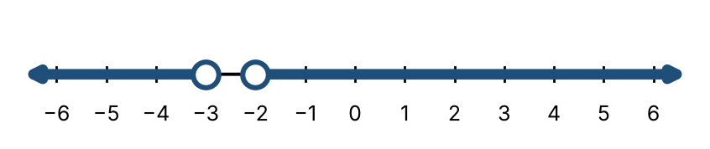

Example 2: solve $\frac{2x+6}{x−2}<0$
Numerator zero at $x=−3$; denominator zero at $x=2$. Test: $x=−4$ gives $\frac{−2}{−6}>0$; $x=0$ gives $\frac{6}{−2}<0$; $x=3$ gives $\frac{12}{1}>0$.
We need negative: (−3, 2).

Example 3: solve $\frac{3+x}{3−x}≥1$
Steps 1–2. Subtract 1 and combine: $\frac{3+x}{3−x}−\frac{3−x}{3−x}≥0$, so $\frac{2x}{3−x}≥0$.
Steps 3–5. Zero at $x=0$ (included); denominator zero at $x=3$ (excluded). Test: $x=−1$ gives negative, $x=1$ positive, $x=4$ negative. Answer: [0, 3).

Practice
a. $(x−5)(x−2)(x+1)>0$ | b. $x{(x−1)}^{2}(x−3)<0$
c. $x^{2}≤4x$ | d. $\frac{x+1}{x−4}≥0$

Skill 3.4: Absolute Value Equations

Key ideas
- $\left|X\right|$ is the distance of X from 0, so it is never ______________ (15).
- If $c>0$, then $\left|X\right|=c$ means $X=c$ or X = ______________ (16).
- If $c<0$, then $\left|X\right|=c$ has ______________ (17). If $c=0$, then $X=0$.
- Two absolute values: $\left|A\right|=\left|B\right|$ means $A=B$ or $A=−B$.

Steps: solve an absolute value equation
- Isolate the absolute value on one side.
- Check the other side. If it is negative, there is no solution.
- Write two equations: one with c and one with −c.
- Solve both equations and check your answers.

Example 1: solve $\left|3x−5\right|−4=6$
Isolate: $\left|3x−5\right|=10$. Then $3x−5=10$ gives $x=5$, and $3x−5=−10$ gives $x=−\frac{5}{3}$.

Example 2: solve $\left|3x+4\right|=−9$
An absolute value is never negative, so there is no solution.

Practice
a. $\left|6x+4\right|=8$ | b. $2\left|x−1\right|+3=11$
c. $\left|2x−3\right|=\left|x+6\right|$ | d. $\left|x+4\right|+7=2$

Skill 3.5: Absolute Value Inequalities

Key ideas
Inequality (c > 0) | Equivalent form | Picture
$\left|X\right|<c$ | $−c<X<c$ | ________ (18) −c and c
$\left|X\right|≤c$ | $−c≤X≤c$ | between, endpoints included
$\left|X\right|>c$ | $X<−c$ or $X>c$ | ________ (19) −c and c
$\left|X\right|≥c$ | $X≤−c$ or $X≥c$ | outside, endpoints included

If c is negative: $\left|X\right|<c$ has ______________ (20), and $\left|X\right|>c$ is true for ______________ (21).

Steps: solve an absolute value inequality
- Isolate the absolute value.
- Check for a negative c (no solution, or all real numbers).
- Less than: write one three-part inequality. Greater than: write two inequalities joined by "or."
- Solve, then write the answer in interval notation.

Example 1: solve $\left|x+1\right|≤1$
$−1≤x+1≤1$, so $−2≤x≤0$: [−2, 0].
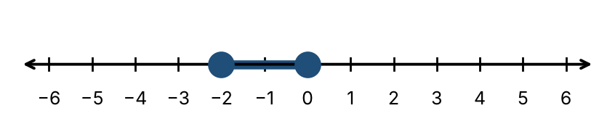

Example 2: solve $\left|x+1\right|≥1$
$x+1≤−1$ or $x+1≥1$, so $x≤−2$ or $x≥0$: (−∞, −2] ∪ [0, ∞).
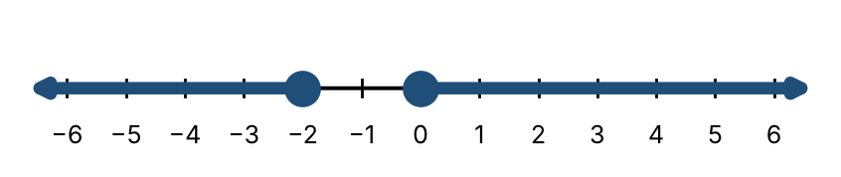

Practice
a. $\left|2x−3\right|<7$ | b. $\left|x−4\right|≥2$
c. $\left|x+1\right|≤−1$ | d. $\left|x+1\right|≥−1$
e. $3\left|x−2\right|+1>10$

Exit check
1. Solve $−3x+4≤10$. Write the answer in interval notation.

2. Solve $x^{2}−x−12<0$.

3. Solve $\left|x−3\right|<5$.

